Vincent Ryan

6/21/2024

Module 5_2 – SQL Three Functions Setup

The first function that I was interested in was “FIND IN SET.” I was very surprised to learn that it found no matching results when I ran the function. I went through a few options, testing upper case vs lower case and it turns out this function finds exact matches. Knowing this I would use this function to find a very specific case, like finding exactly one employee, to pull their record. Were I to give it an alias, it would be the name of that employee since that was the record I was pulling.

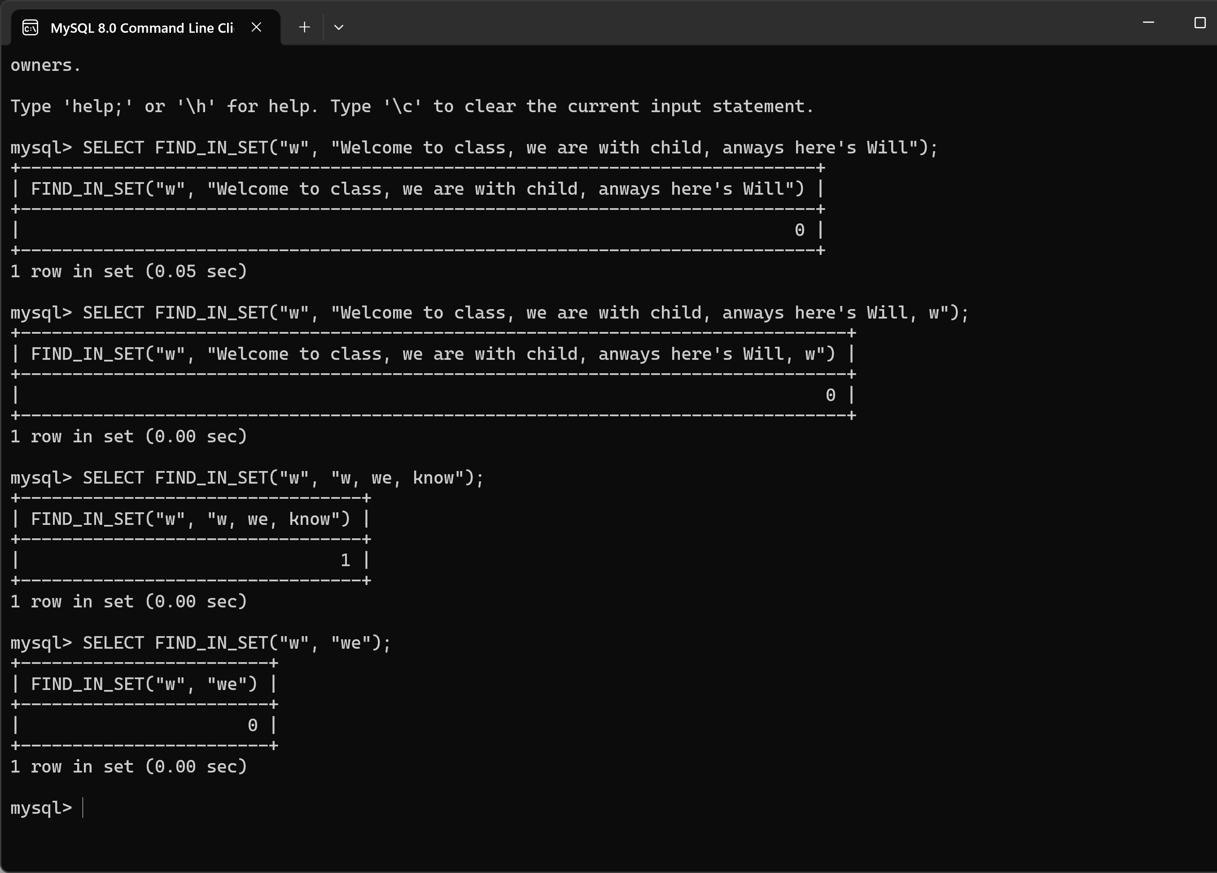

The second function I investigated was POSITION which is the same as the LOCATE function. This feels like a useful component for data normalization. I would use this for (as shown in the example) splitting a full name into a first and last name. Here, you can see that I learned that this function works with “IN” rather than parameters like the last function, which I didn’t pick up on the first time.

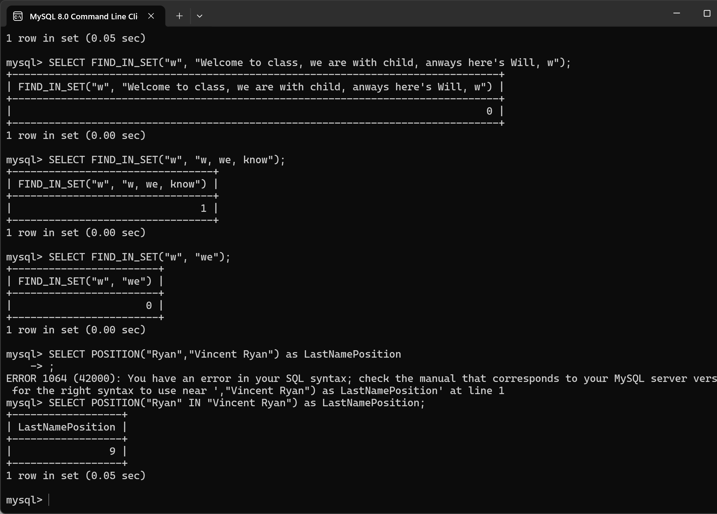

For the third function I used MID which is the same as SUBSTR and SUBSTRING functions. This is very useful for dividing data into smaller more useful parts. In combination with the POSITION answer I can now have the LastName variable I was looking for. Here you can see that I tried using the alias name as the value from the last one, but that errored because they aren’t “variables” as much as they are temporary names. A lot of learning on this assignment.

